**TUGAS PEMROGRAMAN WEB**

1. **WEB DATA DIRI SINGKAT**

* **HTML**
* <!DOCTYPE html>
* <html lang="en">
* <head>
* <meta charset="UTF-8">
* <meta http-equiv="X-UA-Compatible" content="IE=edge">
* <meta name="viewport" content="width=device-width, initial-scale=1.0">
* <title>Document</title>
* <link rel="stylesheet" href="usetable.css">
* </head>
* <body>
* <nav>
* <div class="wrapper">
* <div class="logo"><a href="">DATA DIRI PRIBADI</a></div>
* <div class="menu">
* <ul>
* <li><a href="#home">HOME</a></li>
* <li><a href="#pendidikan">PENDIDIKAN</a></li>
* <li><a href="#jadwalkuliah">JADWAL KULIAH</a></li>
* <li><a href="#aktivitas">AKTIVITAS</a></li>
* <li><a href="#other">OTHER</a></li>
* </ul>
* </div>
* </div>
* </nav>
* <div class="wrapper">
* <section id="home">
* <img src="arif.jpg" alt="" srcset="" width="500px" height="500px">
* <div class="kolom">
* <p class="deskripsi">Informasi Singkat</p>
* <h2>ARIF MUNANDAR</h2>
* <P>Hallo, nama saya Arif Munandar, bisa juga di panggil Arif. Saya lahir di Bima pada hari senin tanggal 29
* April 1996. tidak banyak yang bisa saya jabarkan tentang diri saya sendiri.</P>
* </div>
* </section>
* <section id="pendidikan">
* <div class="kolom">
* <p class="pendidikan">
* <h2>RIWAYAT PENDIDIKAN</h2>
* <hr><br>
* </p>
* <h5>SEKOLAH DASAR</h5>
* <p>SDN Inpres Tente</p>
* <hr><br>
* <h5>SEKOLAH MENENGAH PERTAMA</h5>
* <p>SMP Negeri 1 Woha</p>
* <hr><br>
* <h5>SEKOLAH MENENGAH ATAS</h5>
* <p>SMA Negeri 1 Woha</p>
* <hr>
* </div>
* <img
* src="https://img.freepik.com/free-vector/school-building-educational-institution-college_107791-1051.jpg?w=996&t=st=1668430430~exp=1668431030~hmac=2f7d6a502e4094bf81bee6d7722227669ecf99dc96a4da216ac6fe9d081b6570"
* alt="" width="500px" height="500px">
* </section>
* <section id="jadwalkuliah">
* <div class="tengah">
* <div class="kolom">
* <p class="jadwalkuliah">
* <h2>Jadwal Kuliah</h2><br>
* </p>
* <h5>SABTU</h5>
* <p>08:00 - 09:30 AL ISLAM DAN KEMUHAMMADIYAHAN</p>
* <p>09:30 - 11:00 METODE NUMERIK</p>
* <p>11:00 - 12:30 LOGIKA INFORMATIKA</p>
* <p>13:00 - 15:30 PEMROGRAMAN WEB</p>
* <hr><br>
* <h5>MINGGU</h5>
* <p>08:00 - 09:30 DESAIN GRAFIS</p>
* <p>09:30 - 11:00 PANCASILA</p>
* <p>11:00 - 12:30 BAHASA INDONESIA</p>
* <p>13:00 - 15:30 ALGORITMA DAN PEMROGRAMAN</p>
* </div>
* </div>
* <div class="jadwal">
* <div class="kartu-jadwal">
* <img src="https://img.freepik.com/premium-photo/calendar-with-days-clock-wood-table_43314-1818.jpg?w=740"
* alt="">
* </div>
* </div>
* </section>
* <section id="aktivitas">
* <div class="tengah">
* <div class="kolom">
* <p>RIWAYAT AKTIVITAS</p>
* <hr><br>
* <p>Saya Pernah Bekerja di Perusahaan Automotive <strong><i>PT. Asahimas Flat Glass Tbk</i></strong> sebagai
* admin gudang di salah satu gudangnya di Jakarta Utara Yang khusus untuk menyuplai kaca untuk mobil produksi
* Daihatsu dan Toyota.</p>
* </div>
* <div class="partner-list">
* <div class="kartu-partner">
* <img
* src="https://img.freepik.com/free-vector/illustrated-woman-being-intern-company_23-2148726151.jpg?w=740&t=st=1668433384~exp=1668433984~hmac=2c5c3c1fc1a9c9f34904971fbc2279b4411d2380cdb29ba8dc2c775d166b64c0"
* alt="">
* </div>
* </div>
* </div>
* </section>
* <section id="other">
* <div class="end">
* <h1><b><u>TERIMA KASIH</u></b></h1>
* </div>
* </section>
* </div>
* </body>
* </html>
* **CSS**

* {

  text-decoration: none;

  margin: 0;

  padding: 0;

}

body {

  margin: 0;

  padding: 0;

  font-family: sans-serif;

}

.wrapper {

  width: 100%;

  margin: auto;

  position: relative;

}

.logo {

  font-size: 50px;

  font-weight: 800;

  float: left;

  font-family: 'Courier New', Courier, monospace;

  color: #364f6b;

}

.menu {

  float: right;

}

nav {

  width: 100%;

  margin: auto;

  display: flex;

  line-height: 80px;

  position: sticky;

  position: -webkit-sticky;

  top: 0;

  background: #ffffff;

  z-index: 1;

  border: 1px solid #364f6b;

}

nav ul {

  list-style-type: none;

  margin: 0;

  padding: 0;

  overflow: hidden;

}

nav ul li {

  float: left;

}

nav ul li a {

  color: black;

  font-weight: bold;

  text-align: center;

  padding: 0px 16px 0px 16px;

  text-decoration: none;

}

nav ul li a:hover {

  text-decoration: underline;

}

section {

  margin: auto;

  display: flex;

  margin-bottom: 50px;

}

.kolom {

  margin-top: 50px;

  margin-bottom: 50px;

}

.kolom .deskripsi {

  font-size: 20px;

  font-weight: bold;

  font-family: 'comic sans ms' sans-serif;

  color: #364f6b;

}

h1 {

  font-family: 'comic sans ms' sans-serif;

  font-weight: 800;

  font-size: 45px;

  margin-bottom: 20px;

  color: #364f6b;

  width: 100%;

  line-height: 50%;

}

h2 {

  font-family: 'comic sans ms' sans-serif;

  font-weight: 800;

  font-size: 45px;

  margin-bottom: 20px;

  color: #364f6b;

  width: 100%;

  line-height: 50%;

}

h5 {

  font-family: 'comic sans ms' sans-serif;

  font-weight: 800;

  font-size: 20px;

  margin-bottom: 20px;

  color: #364f6b;

  width: 100%;

  line-height: 10%;

}

p {

  margin: 10px 0 10px 0;

  padding: 10px 0 10px 0;

}

.tengah {

  text-align: center;

  width: 100%;

}

.partner-list {

  width: 100%;

  position: relative;

  display: flex;

}

.end {

  text-align: center;

  width: 100%;

}

* **OUTPUT**

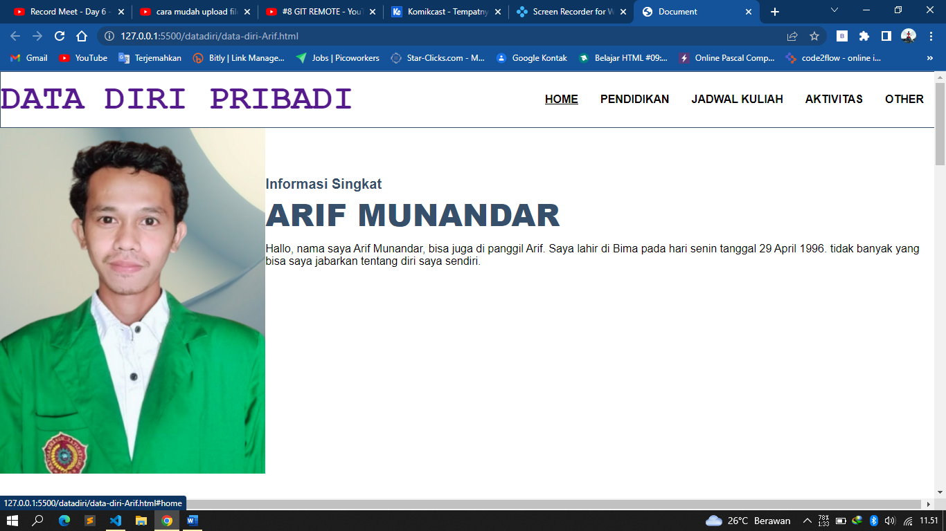

1. **FORM INPUT**

* **HTML**
* <!DOCTYPE html>
* <html lang="en">
* <head>
* <meta charset="UTF-8">
* <meta http-equiv="X-UA-Compatible" content="IE=edge">
* <meta name="viewport" content="width=device-width, initial-scale=1.0">
* <title>Pendaftaran Mahasiswa Baru - UMBima</title>
* <link rel="icon" href="umbima.jpeg">
* <link rel="stylesheet" href="umbima.css">
* </head>
* <body>
* <div class="wrapper-luar">
* <div class="header">
* <h2>FORM PENGISIAN DATA CALON MAHASISWA BARU UNIVERSITAS MUHAMMADIYAH BIMA</h2>
* </div>
* <div class="wrapper-dalam">
* <form action="" method="post">
* <div class="nama">
* <label for="nama">Nama Lengkap</label>
* <input type="text" name="nama" id="nama" placeholder="Nama Lengkap" size="30" required>
* </div>
* <div class="ttlahir">
* <label for="ttlahir">Tempat, Tanggal Lahir</label>
* <input type="text" name="ttlahir" id="ttlahir" placeholder="Tempat Lahir" size="8" required>
* <input type="date" name="ttlahir" id="ttlahir" required>
* </div>
* <div class="alamat">
* <label for="alamat">Alamat</label>
* <input type="text" name="alamat" id="alamat" placeholder="Alamat" size="30" required>
* </div>
* <div class="jeniskelamin">
* <label for="jeniskelamin">Jenis Kelamin</label>
* <label for="lakilaki"><input type="radio" name="jeniskelamin" id="lakilaki" value="Laki-Laki"
* required>Laki-Laki</label>
* <label for="perempuan"><input type="radio" name="jeniskelamin" id="perempuan" value="Perempuan"
* required>Perempuan</label>
* </div>
* <div class="agama">
* <label for="agama">Agama</label>
* <select name="agama" id="agama">
* <option value="Islam">Islam</option>
* <option value="Protestan">Protestan</option>
* <option value="Katolik">Katolik</option>
* <option value="Hindu">Hindu</option>
* <option value="Buddha">Buddha</option>
* <option value="Khonghucu">Khonghucu</option>
* </select>
* </div>
* <div class="telepon">
* <label for="telepon">No. Hp/Telepon</label>
* <input type="tel" name="telepon" id="telepon" placeholder="No. Hp/Telepon" size="30" required
* pattern="(+62|62|0)[0-9]" maxlength="14" minlength="11">
* </div>
* <div class="email">
* <label for="email">E-Mail</label>
* <input type="email" name="email" id="email" placeholder="E-Mail" size="30" required>
* </div>
* <div class="sekolah">
* <label for="sekolah">Asal Sekolah</label>
* <input type="text" name="sekolah" id="sekolah" placeholder="Asal Sekolah (SMA/SMK/DLL)" size="30" required>
* </div>
* <div class="prodi">
* <label for="prodi">Pilih Program Studi</label>
* <select name="prodi" id="prodi">
* <option value="S1 Hukum">S1 Hukum</option>
* <option value="S1 Kewirausahaan">S1 Kewirausahaan</option>
* <option value="S1 Ilmu Komputer">S1 Ilmu Komputer</option>
* <option value="S1 Gizi">S1 Gizi</option>
* <option value="S1 Teknik Sipil">S1 Teknik Sipil</option>
* </select>
* </div>
* <div class="kelas">
* <label for="kelas">Pilih Kelas</label>
* <label for="reguler">
* <input type="radio" name="kelas" id="reguler" value="Reguler" required>Reguler
* </label>
* <label for="ekstensi">
* <input type="radio" name="kelas" id="ekstensi" value="Ekstensi" required>Ekstensi
* </label>
* </div>
* <div class="foto">
* <label for="foto">Upload Foto Latar Biru 4X6</label>
* <input type="file" name="foto" id="foto" required>
* </div>
* <div class="button">
* <button type="submit">Submit</button>
* <button type="reset">Reset</button>
* </div>
* </form>
* </div>
* </div>
* </body>
* </html>
* **CSS**
* * {
* padding: 0;
* margin: 0;
* }
* body {
* background-image: url(umbima.jpeg);
* background-repeat: no-repeat;
* background-position: center;
* background-size: 50;
* display: flex;
* font-family: Arial, Helvetica, sans-serif;
* background-color: rgb(204, 75, 36);
* }
* .wrapper-luar {
* background-color: rgba(240, 248, 255, 0.308);
* width: 700px;
* margin: 50px auto;
* box-sizing: border-box;
* }
* .header {
* text-align: center;
* border-bottom: 10px;
* }
* .wrapper-dalam {
* font-weight: 300;
* display: flex;
* position: relative;
* width: 680px;
* margin: 10px;
* box-sizing: border-box;
* }
* form {
* line-height: 15px;
* display: block;
* font-size: 15px;
* font-family: 'Gill Sans', 'Gill Sans MT', Calibri, 'Trebuchet MS', sans-serif;
* padding: 10px 200px 0 200px;
* }
* label {
* display: block;
* padding-bottom: 1px;
* }
* div {
* margin: 10px;
* }
* **OUTPUT**

